Mah Jong Game

Darin Critchlo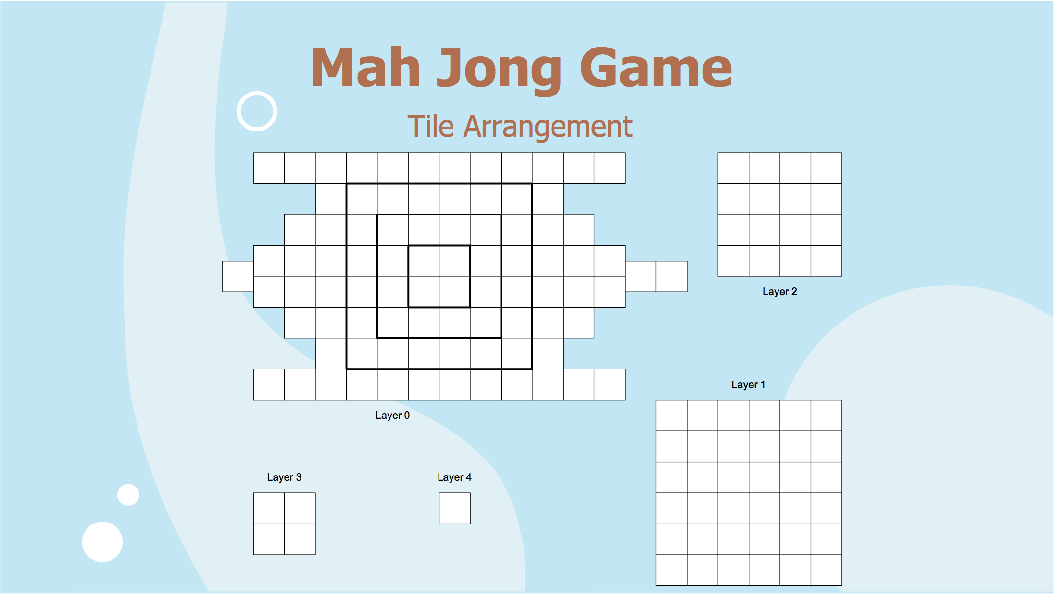w

CS 3230

DATE \@ "MMMM d, y" October 30, 2014

CS 3230 ONL Fall 14 22586

# Objective

Design and code a working version of Mah Jong in Java

## Goals

Design a program using Model View Controller paradigm and other Java best practices

## Algorithms

Test if the tile is surrounded by another tile or if a tile is on top

boolean isTileOpen(Tile t) //(int x, int y, int z)

{

if (t.x - 1 < 0 || x + 1 >= xDim)

return false;

if (t.z + 1 == zDim) // top layer

return tiles[t.x - 1, y, z] == null || tiles[t.x + 1, y, z] == null;

CS 3230

else

return tiles[t.z + 1] = null &&

(tiles[t.x-1, t.y, t.z] = null || tiles[t.x+1, t.y, t.z] == null);

}

Position tile

void positionTile(Tile t, int x, int y, int z)

{

// Give Tile constructor the coordinates it sits on the board

}

Get specific tile

getTile(int x, int y, int z)

{

// return the tile that is currently at those coordinates

return Tile

}

## Model

CS 3230